# Manachers’ Algorithm

The main idea of manacher’s algo is reuse the result

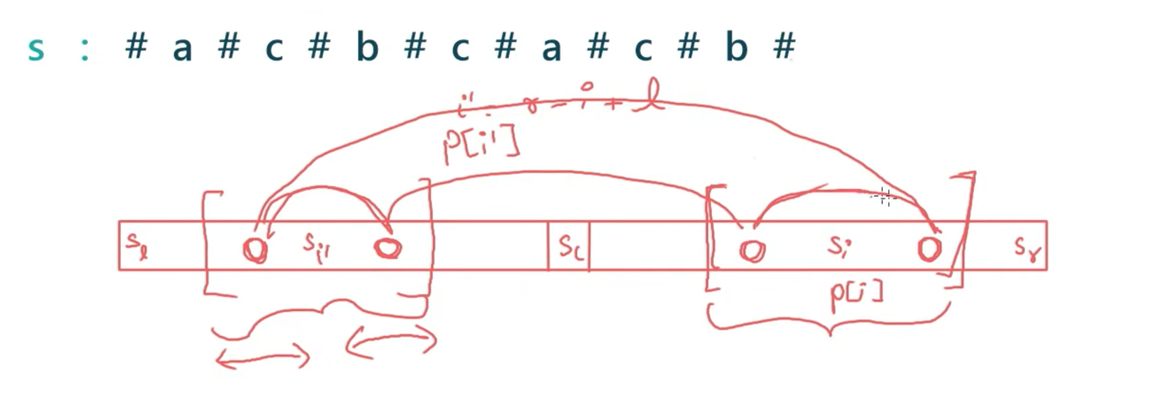

We can use the left part and don’t need to calc for right part until some bound i.e   
min(p[l+r-1],r-i)

Why mini ?  
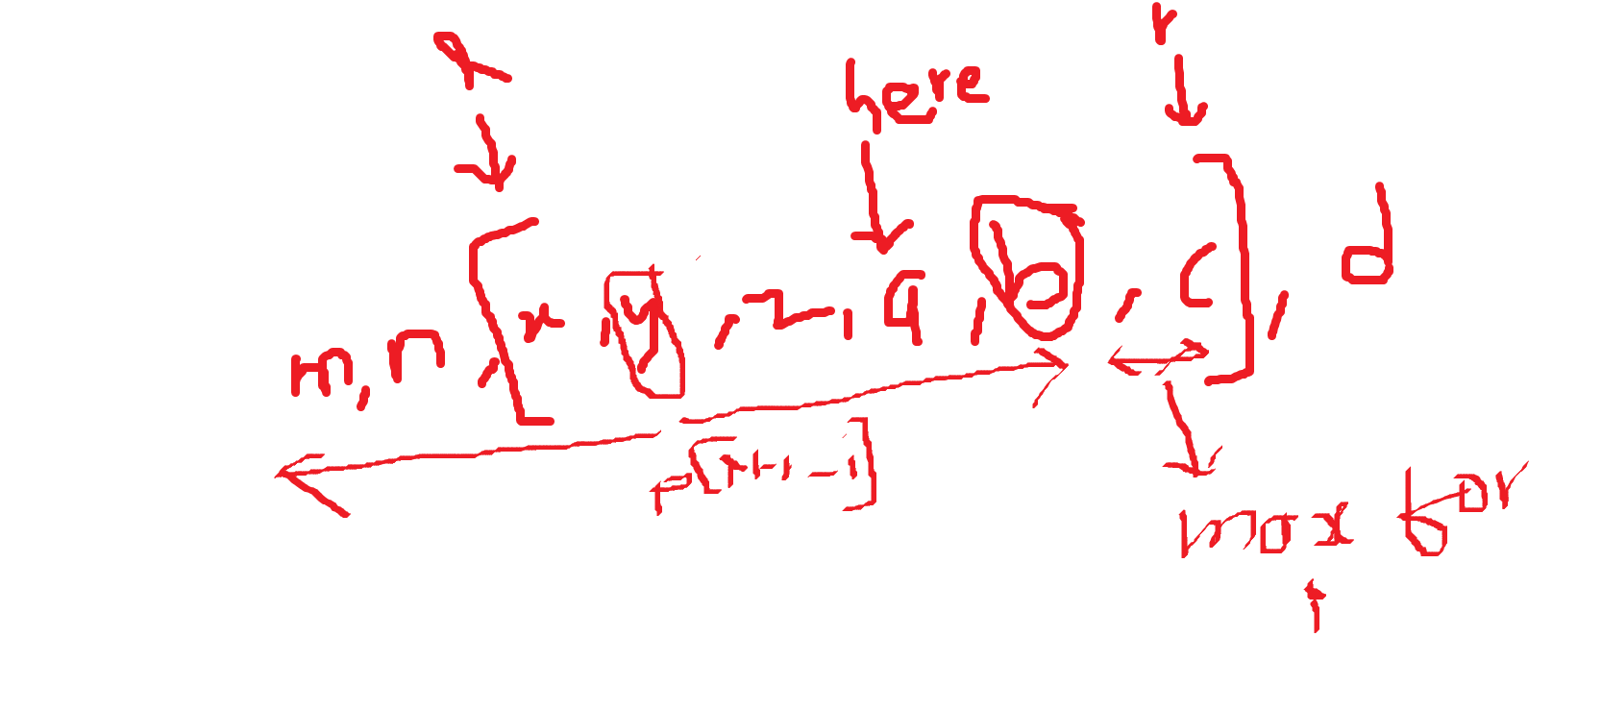

If left has expanded but that space has not been explored by r then its not legal to take the maximum value. Hence we take the minimum value

| P[i] = max(0,min(p[l+r-i],r-i) |
| --- |

Now after we reused the result we just need to check how much can we expand and that the value of p[i].

| while(i< && i>-1 &&s[i+p[i]] == s[i-p[i]]){  p[i]++; } |
| --- |
|  |

IMPORTANT : If curr r i.e i+p[i] goes beyond the prev r then we need to update both l and r

| if(i+p[i]>r){  r = i+p[i];  l = i -p[i];  } |
| --- |

These l and r are the new bounds that we have calculated.

Finding the index and length of a particular index and checking if the [l,r] form a palindrome or not?

1.Finding index of each palindrome :